Case study 5:
Lessons learned

Work Package 3 – Deliverable 3.1
Delivery date: 30/08/2021
Dissemination Level: TBD

Authors: One per case
Lead beneficiary: WNRI

Project full title: Unpacking climate impact chains - a new generation of climate change risk assessments | Project acronym: UNCHAIN
Grant Agreement number: 776608 | Project start date: 1st September 2019
Funding scheme: H2020-SC5-2016-2017 | Duration: 36 months

Title  Lesson learned | Date 30/08/20
Project title  Unpacking climate impact chains. A new generation of action- and user-oriented climate change risk assessments (UNCHAIN) | Number of pages X
Lead authors  Linda Menk | Project leader  Carlo Aall
Contributors
XX
Short summary
XX

Table of contents
Introduction 4
Case brief description 4
Selected Impact Chain 5
Innovation areas and research questions addressed 5
I. Methodological approach to case study and related Impact Chain 7
1. Prepare Vulnerability Assessment (Scoping) 7
2. Developing impact chains 10
3. Identifying and selecting indicators 12
4. Data acquisition and management 14
5. Normalizing indicators 16
6. Weighting 17
7. Aggregating indicators and components 17
II. Results (module 8: presenting VA outcomes) 17
III. Key lessons learned per innovation area 19
Research innovation relating to Impact Chain method 19
Research innovation relating to uncertainties 27
Research innovation relating to co-production of knowledge 27
Research innovation relating to societal change and socio-economic consequences 27
Research innovation relating to transborder climate change risks 27
Appendix: Data flows template 28
Appendix2: Evaluation framework 28

Introduction

Case brief description
Case content
This case aims to develop impact chains, hold stakeholder dialogues and workshops, explore system dynamic approaches and to conduct a quantitative risk assessment that is focused on the co-development of drivers of agricultural drought and derives adaptation approaches. It utilizes causal loop diagrams and integrates systems modelling approaches. Another core element of this case is the application of a spatial regionalisation approach that is independent from administrative boundaries.
Research Innovations
Co-development of drivers of agricultural drought and derivation of adaptation approaches; application of causal loop diagrams as well as integration of systems modelling approaches; application of regionalisation approach which is independent from admin boundaries
Study areas
Province of Salzburg with focus on specific areas
Stakeholders involved
Various - governmental institutions (national, provincial, regional), farmer associations, farmers, insurance representative, scientists
Summary data collection
Qualitative data is gathered through stakeholder dialogues and workshops; Quantitative data, such as socio-demographic and socio-economic data, bio-physical and satellite derived data are collected from various open government data portals and other freely and openly available sources.
Expected results
Spatial risk maps, adapted and improved methodology of IC, insights on stakeholder consultation
Case study responsible
University Salzburg (PLUS)
Context of the vulnerability assessment
The case study takes place at the beginning of the adaptation planning. Drought has not been a problem in Austria until recently (e.g. 2018-2020) and its potential future impacts are still underexplored. There are, to date, only few drought risk assessments for Salzburg/Austria (e.g. Planungstool Trockenheit: https://www.salzburg.gv.at/umweltnaturwasser_/Documents/20201130_LandSBG_PlanungstoolTrockenheit_EndberichtZAMG.pdf), but the topic is gaining traction (e.g. Waterstress: https://iiasa.ac.at/web/home/research/researchPrograms/RISK/WaterStress.html). The scope of future drought risk is still explored. As stakeholders we included in our assessment: Governmental institutions (national, provincial, regional), farmer associations, farmers, insurance representative and scientists.
Objectives and expected outcomes
In our case study, we wanted to get a better understanding of the additional factors that fuel drought risk, besides a negative water balance. This comprises procedural, financial, political and environmental aspects. Furthermore, we wanted to understand these aspects’ relations to each other. Overall, we wanted to assess where in the Salzburg municipality risk is high and where it is low, and why. Thus, we collected, integrated and analyzed a set of spatial datasets that are representatives of each influencing aspect. The assessment results are intended to raise awareness among the involved stakeholders for the drought topic. They are supposed to understand the benefits of taking a holistic perspective on a particular problem, with a focus on the relationships between different risk aspects. The target audience for the assessment results are the stakeholders.
Our assessment focuses on future risk. We assess, whether or not probability of very dry and very wet years will increase in 2021-2050 and 2071-2100 compared to 1981-2010.
Involved researchers were Linda Menk (PLUS), Stefan Kienberger (PLUS), Markus Leitner (UBA), Martina Offenzeller (UBA), Marc Zebisch (Eurac), Stefano Terzi (Eurac).

Selected Impact Chain
Risk of financial loss for farmers due to agricultural drought in Austria

Innovation areas and research questions addressed
The key research questions that we have addressed in this case study are shown below.
Innovation area “Impact Chain Model & Uncertainty”
1.2. How to identify the relevant system elements and their interrelations when doing impact chain analysis?(How did we identify…)?
3. How to integrate in the impact chain framework knowledge from other approaches already existing in literature on the normalization and aggregation phases and the definition of critical thresholds?
4. How to address limitations in the availability of reliable data? (heterogeneity, spatial/temporal resolution, the mismatch between resolution)
5. How to forward the impact chain approach from a ‘linear’ representation of risk components towards more system dynamics-oriented models?
Innovation area “Co-production of knowledge”
2. How was results from the climate risk assessment perceived by stakeholders and scientific knowledge providers?

Methodological approach to case study and related Impact Chain
We suggest here to follow the vulnerability sourcebook modules to facilitate linkages with WP5 deliverable.
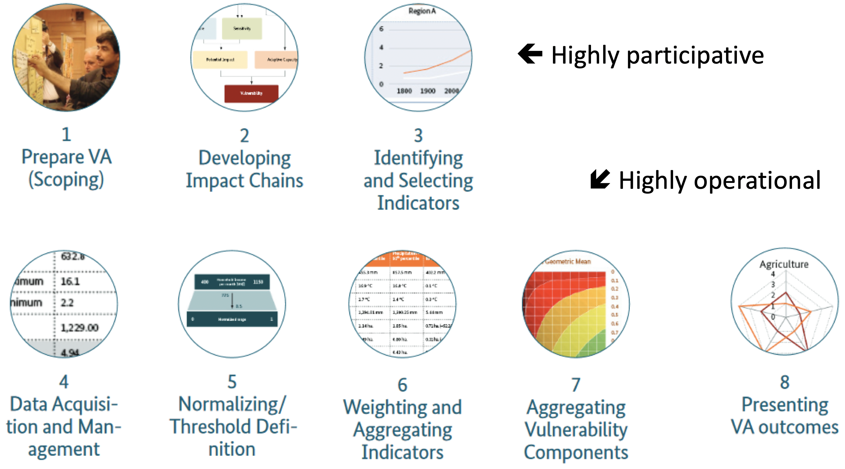

Prepare Vulnerability Assessment (Scoping)
RQ addressed
1.2. How to identify the relevant system elements and their interrelations when doing impact chain analysis?(How did we identify…)?
5. How to forward the impact chain approach from a ‘linear’ representation of risk components towards more system dynamics-oriented models?

Process
We decided that the System Dynamics approach is suitable to depict a phenomenon, such as the risk of agricultural drought, since the underling components that fuel drought risk are manifold and interconnected. This assumption held true, which can be checked in our outcome document which shows our final Impact Chain.
Due to the Covid-19 situation, the Impact Chain diagram was not developed together with the stakeholders. This was because we had a rather short online workshop in June 2020 where we only collected elements to be integrated into the Impact Chain, rather than their relationships.

The basis for the idea to integrate dynamics into the assessment has been developed in precursory work. Based on a risk assessment that focused on the risk of vector-borne diseases in East Africa, systemically homogenous spatial clusters were derived and data driven Causal Loop Diagrams were generated. This workflow was developed using the statistical programming language R. The script can easily adapted for other contexts. Our aim was to test this approach in a different context, which was the Austrian agricultural drought context.

Furthermore, in addition to the data-driven CLDs, we wanted to forward the Impact Chain development process from a depiction that shows risk-contributing-factors trickling down into the box that says “Risk” (as suggested in the Vulnerability Sourcebook). Towards a more dynamic depiction that integrates system dynamics notations (red and green arrows describing reinforcing or balancing relationships), where also the risk-contributing-factors can have relationships among each other. The idea behind this notation is to communicate cause-effect relationships to the stakeholders. We used the Software InsightMaker for this.

This means that we have developed a qualitative System Dynamics model (a qualitative Causal Loop Diagram (Outcome of Module 2)) and a more quantitative model (a set of data-driven Causal Loop Diagrams).

Outcomes
The outcome of the scoping phase was a workflow overview document (and is shown below):
3. Workpackages > WP3 Case studies Implementation > Case 05_Austria > UNCHAIN_Workflow_Overview.pdf
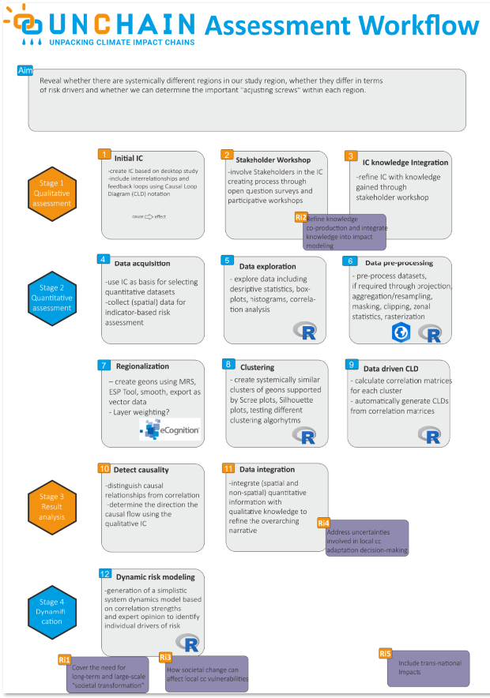
Figure 1: The outcome of the scoping phase was a workflow overview document.

Developing impact chains
RQ addressed
1.2. How to identify the relevant system elements and their interrelations when doing impact chain analysis?(How did we identify…)?
5. How to forward the impact chain approach from a ‘linear’ representation of risk components towards more system dynamics-oriented models?

Process
We initially planned to conduct a stakeholder workshop in which we would develop Impact Chains concerning the potential impacts caused by drought on the Austrian agricultural sector. However, due to the Covid-19 Situation in early 2020, we had to conduct the event in online mode. To not overstress our stakeholders with too long online discussions, we shortened the workshop to 2.5 hours in total. This included the presentation of the project UNCHAIN, a presentation on drought and the expected climatic changes in this regard in Austria, and the presentation of the Impact Chain modeling approach. The rest of the time was dedicated to the discussion of factors which, in the opinion of the stakeholders, would also impact the Austrian agricultural sector. We anticipated that the limited timeframe would not be sufficient to hear everyone’s standpoints and opinions. Therefore, we asked the stakeholders in advance to fill an online survey, answering the following questions:

- What effects does drought have on your company or on your clientele?
- Which environmental factors (as the cause) do you think are responsible for drought?
- What other factors do you see as the cause of drought? (e.g. social, economic/ operational or procedural causes)
- What measures are already helping now?
- Which measures could help in the future? (Predictive and long-term measures)
The participants answered the survey in advance and we collected their answers in with the Software “Mural”, where we already had clustered similar answers. This Mural served as the basis for discussion during the workshop. It fostered a lively discussion and we gained interesting insights.
The online survey was a good idea in order to collect numerous standpoints in a relatively short timeframe. It also revealed differing standpoints that probably would not have come up during a discussion as it might have sparked conflicts. However, the time that was reserved for discussion was too short to develop Impact Chains that include opinions on cause and effect relationships. After the workshop we asked the participants to have a look at the Mural again and re-arrange items that they perceived should be clustered and we asked them to fill out a post-workshop survey. However, both were picked up by just a few stakeholders.

After the first workshop we developed Impact Chains among the project group, based on the information we gathered during the survey, the online workshop and a literature review. The Impact Chains functioned as the basis for indicator selection, data acquisition and analysis.

Outcomes
Our Impact Chain is available in 3. Workpackages > WP3 Cast studies Implementation > Case 05_Austria > UNCHAIN_Drought_ImpactChain_v2.JPG

We have developed a workflow guide for developing Impact Chains with Stakeholders in an online Workshop: 3. Workpackages > WP3 Case studies Implementation > Case 05_Austria > UNCHAIN_Drought_ImpactChain_v2.JPG > IC_documentation.docx
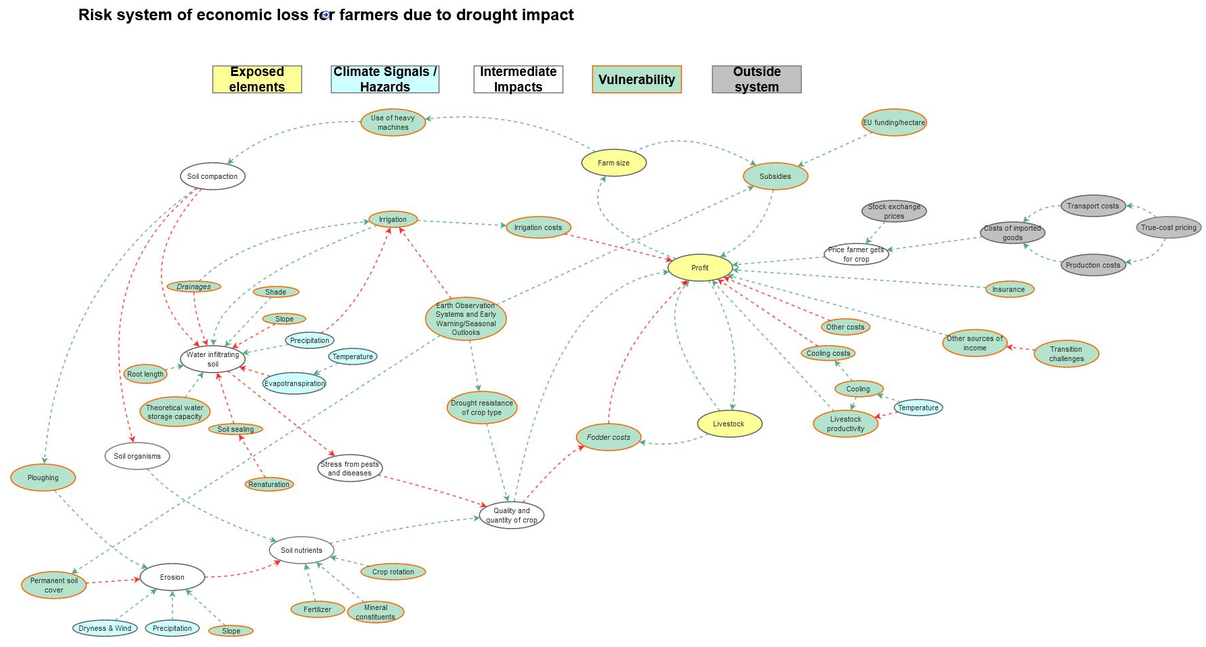
Figure 2: The Impact Chain we developed based on stakeholder input, literature review and expert knowledge
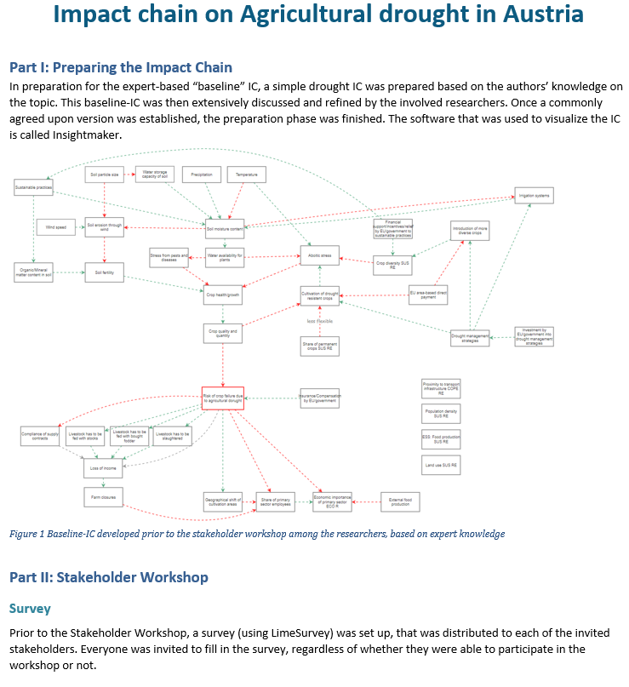
Figure 3: We have described our approach in a workflow documentation

Identifying and selecting indicators
RQ addressed
1.2. How to identify the relevant system elements and their interrelations when doing impact chain analysis?(How did we identify…)?
3. How to integrate in the impact chain framework knowledge from other approaches already existing in literature on the normalization and aggregation phases and the definition of critical thresholds?
4. How to address limitations in the availability of reliable data? (heterogeneity, spatial/temporal resolution, the mismatch between resolution)
Process
The identification of indicators and the acquisition of data was a cyclical process. Our aim was to find a spatial data set for each element in our Impact Chain. Before defining indicators, we reviewed all available spatial datasets available for Austria on Open Government and other data portals. We saved those datasets for later which sounded promising in the context of agricultural drought and later on decided which data set could be used to represent which indicator/element of the Impact Chain. For those datasets where we were not sure, whether they would make good proxies for our indicators, we asked experts for their advice (e.g. on the relationship between soil characteristics and their potential to store water). We collected all relevant information in an Excel Sheet: Element of the Impact Chain, Indicator, data set to represent the indicator, justification why this dataset would make a good indicator for a given Impact Chain element, source, year of acquisition, spatial resolution, etc.
For some Impact Chain elements we could not find appropriate, publicly available indicator data. In these cases we specifically contacted some of the stakeholders of who we knew that they probably have access to certain data. Some of the data gaps could be closed with this approach. However, some data gaps still remained open after finalization of the data retrieval phase. We noted these gaps down and also included them in the final presentation of the outcomes to the stakeholders.

For the hazard indicator we were in contact with the Austria MET Office who provided us with modeled precipitation data up to the year 2100. In close contact with them, we calculated several hazard indicators from this data. The Standardized Precipitation Indicator (SPI) did not make it as our final indicator, however, the script we developed along the way is not available as an R-package on Github: https://github.com/Menkli/SPIspatial
Outcomes
Our Indicator description is available in 3. Workpackages > WP3 Case studies Implementation > Case 05_Austria > Final_indicator_description.xslx
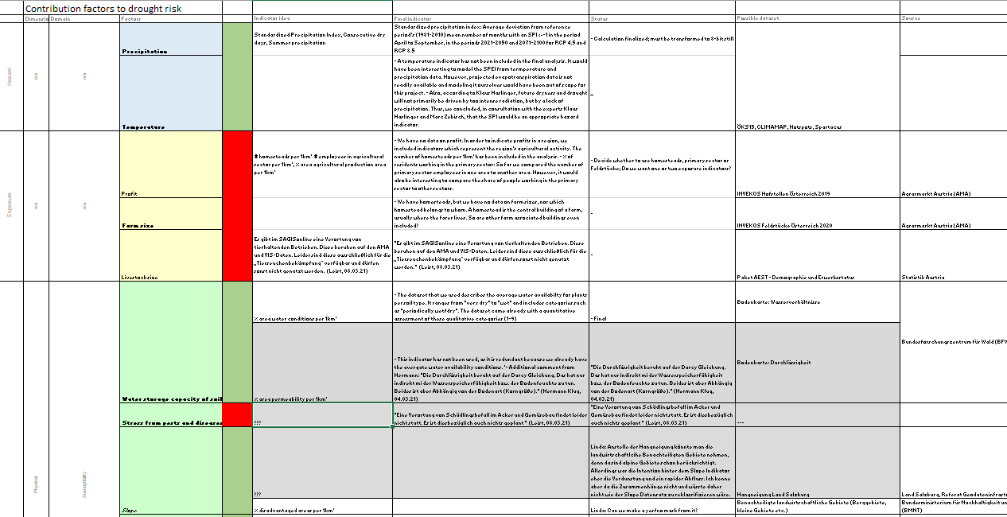
Figure 4: In an Excel file we collected information on IC elements, indicators and data sources

Data acquisition and management
RQ addressed
4. How to address limitations in the availability of reliable data? (heterogeneity, spatial/temporal resolution, the mismatch between resolution)
Process
For more detail see description under 3. Identifying and selecting indicators.
Most of our indicator data we were able to download freely from the internet, while some other data we received from our stakeholders. We harmonized and integrated the datasets using the statistical programming language R. Data sets were first loaded, then reprojected in case they came in the wrong Coordinate Reference System. Then they were then cropped to our study area, aggregated to 1km² raster cells, scaled from 0 to 255 (8-bit), reclassified where necessary (for example so that high values represent high vulnerability while low values represent low vulnerability), plotted and exported as a raster brick. This raster brick was then further analysed using the Image Analysis Software eCognition to derive so-called geons, regions of relatively homogenous risk, based on the inner variance amongst all risk dimensions. These geons were generated for two RCPs (4.5 & 8.5) and two timespans (2021-2050 & 2071-2100). Using our results, we build a R-Shiny Dashboard which can be interactively explored by users.
Outcomes
Our data and our processing and analysis steps/script can be found in 3. Workpackages > WP3 Case studies Implementation > Case 05_Austria > 01_UNCHAIN_dataprocessing_upd.html

All scripts and documentation, as well as the code for the dashboard with the results is publicly available on Github: https://github.com/Menkli/spatial-risk-tools
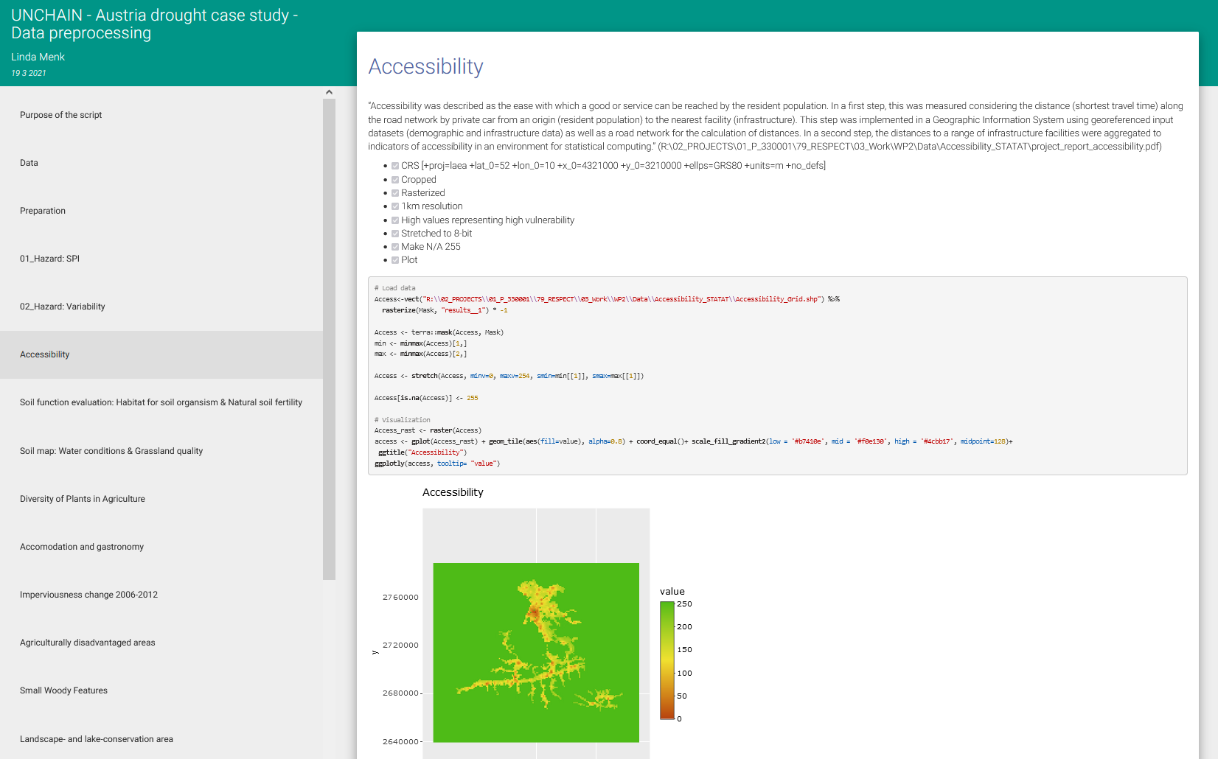
Figure 5: The data we used and the processing steps performed on them can be viewed in a separate document.
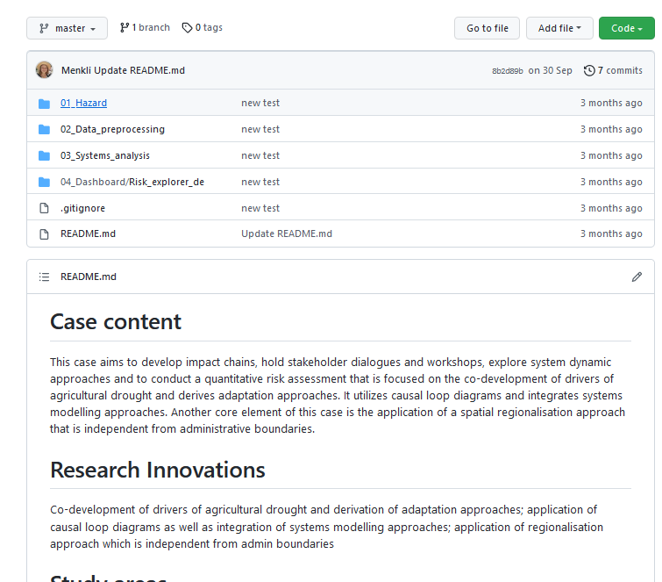
Figure 6: All code developed during the course of the case study can be accessed via Github

Normalizing indicators
RQ addressed
3. How to integrate in the impact chain framework knowledge from other approaches already existing in literature on the normalization and aggregation phases and the definition of critical thresholds?

Process
We normalized the indicators to fit a scale ranging from 0-255. This resembles 8-bit. We did that to be able to analyse the data in an image analysis software, which is usually used to analyse satellite imagery. After this analysis step, we re-scaled it to fit a 0-1 scale. 0 indicates no risk and 1 indicates the highest risk relative to the whole assessment area. This means we followed a rather straight-forward approach and did not integrated any innovations/extensions to the Vulnerability Sourcebook in this step.
Outcomes

Weighting
RQ addressed
3. How to integrate in the impact chain framework knowledge from other approaches already existing in literature on the normalization and aggregation phases and the definition of critical thresholds?
Process
All our indicators weight the same. This is a pretty straight-forward approach and does not integrate any Innovation.
Outcomes

Aggregating indicators and components
RQ addressed
3. How to integrate in the impact chain framework knowledge from other approaches already existing in literature on the normalization and aggregation phases and the definition of critical thresholds?
Process
We separated our indicator data into three groups: The hazard indicators, the exposure indicators and the vulnerability indicators. In the final risk index, the three groups weighted 1/3 each. However, we had [] vulnerability indicators, 2 exposure indicator and 1 hazard indicator. This means that the single hazard and exposure indicators weighted much more in the final result than a single vulnerability indicator.
We refrained from assigning expert-based weights to the single indicators.

Outcomes

Results (module 8: presenting VA outcomes)

RQ addressed
5. How to forward the impact chain approach from a ‘linear’ representation of risk components towards more system dynamics-oriented models?

Process
Our second workshop took place on 21 September 2021 and was also held online. This made it easier for stakeholders to attend the event. We had a follow up presentation on the most recent scientific findings concerning the projected drought development in Austria and a presentation of the preliminary results of our case study. The objective was to see as to whether the results reflected their expectations and to what extent they were able to validate our assessments results. We were also interested in whether such scientific findings were relevant for their work/the decisions that they take.

Unfortunately, only four stakeholders visited the event. This might be due to the long break between the first and the second workshop. However, they were mostly satisfied with the Impact Chain depiction that we had prepared based on our last workshop. Only minor changes were demanded which we did afterwards. The visual and interactive presentation of our quantitative assessment was also perceived positively, however, not discussed in much detail.
The depiction of the Impact Chain as a System Dynamics Causal Loop Diagram was perceived well. One participant stated that when deciding on funding and subsidies, agencies and ministries often only have the short-term perspective in mind, while this type of visualization allows for a holistic perspective that also hints of mid- and long-term implications of a decision.
However, the depiction as is was perceived as too crowded and complicated and it was suggested to split the depiction up in smaller sub-systems.

Outcomes
A stakeholder workshop/A interactive dashboard. It is not currently running online, only the code is available (would need to be downloaded and run in RStudio). However, a series of screenshots in available in in 3. Workpackages > WP3 Case studies Implementation > Case 05_Austria > Dashboard.pdf
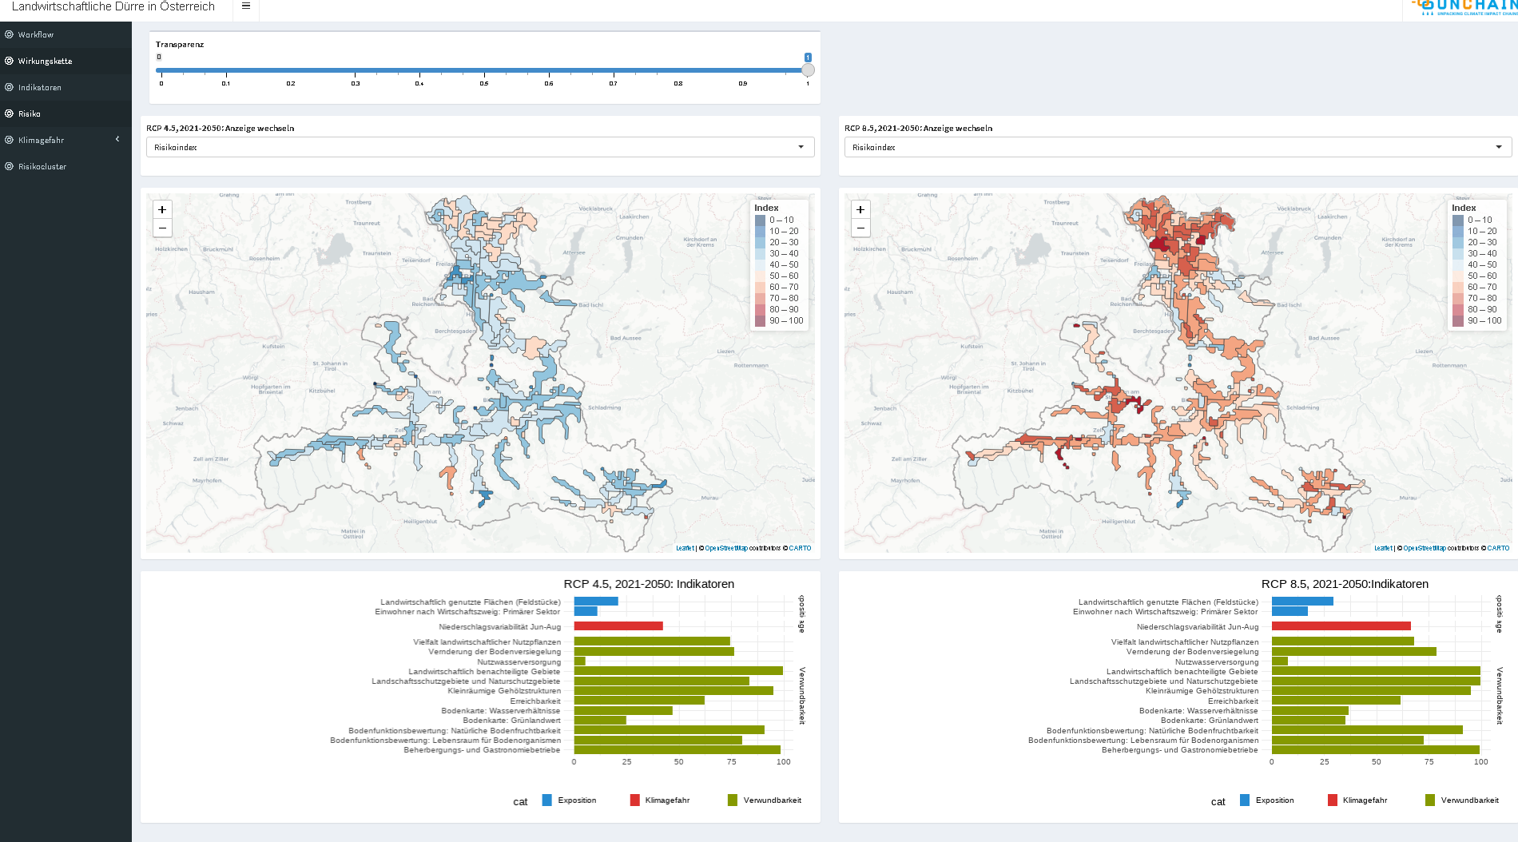
Figure 7: The results dashbaord the way it was presented to the stakeholders

Key lessons learned per innovation area

Research innovation relating to Impact Chain method
- Have you extended your methodology beyond what is described in the Vulnerability Sourcebook (this can be related to the 5 Innovations, but does not have to)?

Yes

- How does your methodology extend the original Vulnerability Sourcebook methodology?

We have extended our method beyond the Vulnerability Sourcebook. We extended the “Core Impact Chain method”. We have
a) Depicted the Impact Chain diagram using Causal Loop Diagram notations,
b) applied a spatial regionalization technique on quantitative data that defines regions of rather homogenous risk, and
c) from these regions, we derived two risk regimes that are different in their internal structures and analysed their characteristics. The results of this exercise are presented in 3. Workpackages > WP3 Cast studies Implementation > Case 05_Austria > 01_UNCHAIN_clusters.html (To see the results, download the .html file, right click and open it in any browser).

- Which Sourcebook modules do your methodological extensions refer to (Which Sub-research question relates to which module can be looked up in the Case Study Protocol D2.1)?

Extension a) refers to the research question 5. How to forward the impact chain approach from a ‘linear’ representation of risk components towards more system dynamics-oriented models? This question is connected to the Sourcebook Modules M1-M8.

Extension b) refers to the research question 3. How to integrate in the impact chain framework knowledge from other approaches already existing in literature on the normalization and aggregation phases and the definition of critical thresholds? This question is connected to the Sourcebook Modules
M1, M5, M6, M7.

Extension c) also refers to the research question 5. How to forward the impact chain approach from a ‘linear’ representation of risk components towards more system dynamics-oriented models? This question is connected to the Sourcebook Modules M1-M8.

- d) How do your rate your methodological extensions in terms of the following validation criteria (short written reflections). Please repeat the filling of the table for each Sourcebook module that you have methodologically extended.

Extension a): Depicting the Impact Chain diagram using Causal Loop Diagram notation
Criteria | Requirement | Answer
Relevance | Supports the identification of climate risks with the option to identify climate change adaptation measures - based on impact chains - with the aim to derive a quantitative and qualitative (or both combined) climate risk assessment | Yes, in particular the cause-effect oriented notation style of the impact chain was perceived as well equipped to support the identification of climate risks and possible entry points for adaptation measures. The quantitative results must be handled with case, as they include some proxy indicators and modelled climate data.
Applicability | The method is generic in its application as well as not limited to exclusive/commercial toolsets | Yes, to apply it, we basically just use red and green arrows. Red arrows stand for a balancing relationship between two variables (if A increases, B decreses); green arrows stand for a reinforcing relationship (if A increases, B increases). If this is done for all variable pairs in the system, feedback loops can be identified, which can also be labelled as reinforcing or balancing, based on the number of red and green arrows. Identifying feedback loops allows to better understand whether a system will wear down over time or whether it will get out of hand to eventually collapse.
Comprehensibility | The method is documented and guidance is provided | This notation is well known in System Dynamics. New users must be told the meaning of the red and green arrows and that the graphic is read one variable pair after the other. After having understood that, it is simple. It is well documented in the internet when looking for Causal Loop Diagrams.
Scientific Validity | The approach is scientifically valid (and re-producible) and has undergone a review (e.g., by another expert round, review etc.) | The notation style it frequently applied in the scientific literature of System Dynamics. We showed our result to our stakeholders and they agreed with it, except for minor changes which we adapted afterwards. The systemic perspective of this notation style was perceived as valuable for mid- and long-term impacts of adaptation decisions.
 | The impact chains are based on a diverse set of stakeholder knowledge together with scientific findings | Yes, they were developed with stakeholders, based on literature and among the research group.
Effectiveness | The method can be implemented without primary data collection (i.e., it can build on existing datasets) | -
 | The method allows the integration of data from heterogenous data sources (quantitative, qualitative, expert, stakeholder...) | -
 | It can be implemented within a feasible timeframe and practicable team size | Yes, it just requires access to knowledge of all relevant system elements and whether they have a reinforcing or a balancing relationship.
 | It involves stakeholders in all its main phases | It involved stakeholders in the development and in the validation phase.
Transferability | The method can be transferred to other application/sector contexts | Yes, it can be applied to all contexts.
 | It can be transferred to other geographical settings | Yes, it can be transferred to all geographic settings.
Scalability | The method can be applied at different geographical scales (local, provincial, national, regional...) | Yes, it can be transferred to all geographic scales.
 | It can be scaled across varying numbers of assessment units (e.g., 3-4 admin units vs. 15-20 admin units) | -
Would you suggest this extension to be integrated into an updated version of the Vulnerability Sourcebook?

Yes, this method passed all the validation criteria and we would see it as a valuable addition in the toolbox of the Vulnerability Sourcebook.

Extension b) Applying a spatial regionalization technique on quantitative data that defines regions of relatively homogenous risk

Criteria | Requirement | Answer
Relevance | Supports the identification of climate risks with the option to identify climate change adaptation measures - based on impact chains - with the aim to derive a quantitative and qualitative (or both combined) climate risk assessment | Yes, regions of homogenous risk are usually not congruent with administrative regions. Therefore it is very useful to have a clear overview of the spatial distribution of actual risk. However, since decisions are usually made on the administrative unit, it is useful to display the outlines of the administrative units alongside the homogenous risk regions.
Applicability | The method is generic in its application as well as not limited to exclusive/commercial toolsets | It was conducted using the commercial software eCognition. Thus, it is limited to exclusive toolsets. Furthermore, the software was utilized to do something it was not necessarily designed for, which means this workflow requires a lot of background knowledge.
Comprehensibility | The method is documented and guidance is provided | The method has been applied in several research projects where it is described on a very high level. However, no detailed technical guidelines on the actual workflow exists to date. Instructions are internally passed on to the next researcher at Z_GIS.
Scientific Validity | The approach is scientifically valid (and re-producible) and has undergone a review (e.g., by another expert round, review etc.) | The approach is scientifically valid – it has been applied and was described in several publications. It is also reproducible, since it is based on scripts. However, as described before, reproducing the result is only possible when having access to the software and a detailed description of the workflow.
 | The impact chains are based on a diverse set of stakeholder knowledge together with scientific findings | -
Effectiveness | The method can be implemented without primary data collection (i.e., it can build on existing datasets) | Yes, It can be build on any spatial data that is present in raster format (e.g. as .tif files).
 | The method allows the integration of data from heterogenous data sources (quantitative, qualitative, expert, stakeholder...) | Yes, It can be build on any spatial data that is present in raster format (e.g. as .tif files).
 | It can be implemented within a feasible timeframe and practicable team size | Yes, once data is prepared and instructions are clear, the workflow is pretty straight forward and fast.
 | It involves stakeholders in all its main phases | -
Transferability | The method can be transferred to other application/sector contexts | Yes, it has been applied in several studies in different contexts.
 | It can be transferred to other geographical settings | Yes, it has been applied in several studies in other geographical contexts.
Scalability | The method can be applied at different geographical scales (local, provincial, national, regional...) | Yes, it can be applied at different geographical scales, including several scales at once, since this approach allows for nested hierachy.
 | It can be scaled across varying numbers of assessment units (e.g., 3-4 admin units vs. 15-20 admin units) | Yes, the number of assessment units can be scaled to the most appropriate number of units.
Would you suggest this extension to be integrated into an updated version of the Vulnerability Sourcebook?
Being able to delineate regions of homogenous risk that are independent from administrative boundaries is a valuable ability. However, not everyone does their risk assessment spatially explicit. This extension only applied for those who do.
The way we implemented this extension has its limitations: We used a commercial remote sensing software that is only available to very few researchers and the exact procedure is not thoroughly documented. Alternative Open Source approaches should be explored and documented – then it would be fit for integration into the Sourcebook workflow.
Extension c) Deriving risk regimes that are different in their internal structures and analyse their characteristics.

Criteria | Requirement | Answer
Relevance | Supports the identification of climate risks with the option to identify climate change adaptation measures - based on impact chains - with the aim to derive a quantitative and qualitative (or both combined) climate risk assessment | Yes, it is relevant to better understand which risk regimes/structures govern the risk in a given area. These structures can vary throughout space and are therefore useful to understand.
Applicability | The method is generic in its application as well as not limited to exclusive/commercial toolsets | It is a bit tricky in its application, because it requires the user to be familiar with the programming language R. Also, the script has to be adapted for each new project, i.e. rename variable names, plot headers etc. However, R is open source and not a commercial toolset.
Comprehensibility | The method is documented and guidance is provided | The method is documented in a master thesis and a paper, the code is publicly available on Github. However, its comprehensibility for new users has not been tested yet and the code was mostly developed for internal use.
Scientific Validity | The approach is scientifically valid (and re-producible) and has undergone a review (e.g., by another expert round, review etc.) | The approach has been applied and is documented in a peer-reviewed paper.
 | The impact chains are based on a diverse set of stakeholder knowledge together with scientific findings | -
Effectiveness | The method can be implemented without primary data collection (i.e., it can build on existing datasets) | Yes, it is just a method to cluster and analyse quantitative data. Where the data comes from does not make a difference.
 | The method allows the integration of data from heterogenous data sources (quantitative, qualitative, expert, stakeholder...) | Yes, It can be built on any data set (spatial or non-spatial). However, the data must first be processed and values for each region must be present in table format.
 | It can be implemented within a feasible timeframe and practicable team size | Yes, since it has been pre-scipted it can be adapted for any project relatively quickly.
 | It involves stakeholders in all its main phases | -
Transferability | The method can be transferred to other application/sector contexts | Yes, it can be applied to all contexts.
 | It can be transferred to other geographical settings | Yes, it can be transferred to all geographic settings.
Scalability | The method can be applied at different geographical scales (local, provincial, national, regional...) | Yes, it can be transferred to all geographic scales.
 | It can be scaled across varying numbers of assessment units (e.g., 3-4 admin units vs. 15-20 admin units) | -
Would you suggest this extension to be integrated into an updated version of the Vulnerability Sourcebook?
This extension was rather experimental and is, while from the research perspective interesting, not yet fit for integration into the Vulnerability Sourcebook.

Research innovation relating to uncertainties

Research innovation relating to co-production of knowledge

Research innovation relating to societal change and socio-economic consequences

Research innovation relating to transborder climate change risks

Appendix: Data flows template
Step 1: Extracting an overview | Lead question 1: Is this aspect of the data flow of relevance?
 | Data as input: systematic identification of relevant data gaps and potential synergies across case studies | Data as input and/or output: identification of the role of scale, mismatch between scientific, political, administrative system borders |  | Data flow to Impact Chain analysis: weighting, normalization, identification |  | Relevance of specific indicators for decision support
Name of case study | Please explain | Please explain |  | Please explain |  | Please explain
 | Lead question 2: Are you aware of data sets in other case studies which might be of use to you?
Name of case study | Please explain

Appendix2: Evaluation framework

